A PROJECT REPORT
ON

“Pulp Manufacturing Process in a Paper Mill”

UNDERTAKEN AT

“MIT School of Distance Education”

IN PARTIAL FULFILMENT OF

“Enrolled Course Name”

MIT SCHOOL OF DISTANCE EDUCATION, PUNE.

GUIDED BY
“Name of Guide Provided in Guidelines”

SUBMITTED BY
“Amod Kumar Singh”

STUDENT REGISTRATION NO.: MIT202312345

MIT SCHOOL OF DISTANCE EDUCATION PUNE - 411 038

YEAR 2025-26

Exempt Certificate - If you’re not able to provide the Project Executed Certificate

To
The Director
MIT School of Distance Education, Respected Sir,
This is to request you to kindly exempt me from submitting the certificate for Project Work due to the reason mentioned below:
Tick the right option
1. As per the Rules of the Organisation
- 2. Self Employed
- Working in Public Sector
- Full-time Student

Thanking you in anticipation of your approval to my request. Regards

Student Sign: - Student Name:- Student ID:

DECLARATION

I hereby declare that this project report entitled “Subject Name of Project Report” bonafide record of the project work carried out by me during the academic year 20XX-202XX, in fulfillment of the requirements for the award of “Enrolled Course Name” of MIT School of Distance Education.

This work has not been undertaken or submitted elsewhere in connection with any other academic course.

Sign:-

Name:-

Student ID: MIT202

ACKNOWLEDGEMENT

I would like to take this opportunity to express my sincere thanks and gratitude to “Guided by”, Faculty of MIT School of Distance Education, for allowing me to do my project work in your esteemed organization. It has been a great learning and enjoyable experience.
I would like to express my deep sense of gratitude and profound thanks to all staff members of MIT School of Distance Education for their kind support and cooperation which helped me in gaining lots of knowledge and experience to do my project work successfully.
At last but not least, I am thankful to my Family and Friends for their moral support, endurance and encouragement during the course of the project.

Sign:-

Name:-

Student ID: MIT202

ABSTRACT
This study focuses on the pulp manufacturing process in a paper mill, which is the primary stage in paper production where raw materials are converted into pulp fibers suitable for paper making. Pulp manufacturing represents the integration of industrial technology, resource management, and operational efficiency to produce quality paper products. The objective of this project is to understand the complete pulp production cycle, identify the major stages involved in pulp preparation, and analyze the operational and managerial factors that influence efficiency, cost control, and sustainability in a paper mill environment.
The pulp manufacturing system generally begins with the selection and preparation of raw materials such as wood, bamboo, or agricultural residues. These materials undergo processes including debarking, chipping, and screening before entering the pulping stage. Mechanical and chemical pulping methods are used to separate cellulose fibers from lignin, followed by washing, screening, and bleaching processes to improve pulp purity, brightness, and strength. Modern paper mills integrate automated machinery and chemical recovery systems to enhance productivity while minimizing waste and energy consumption. The process also involves water treatment and recycling systems, which play a crucial role in maintaining environmental standards and reducing industrial pollution.

The findings indicate that there is a substantial level of awareness regarding e- banking among the population of Ahmedabad. The majority of respondents acknowledged the existence of e-banking services and demonstrated familiarity with various digital banking platforms. Additionally, the study revealed that the convenience and flexibility offered by e-banking were the primary drivers for its adoption.

The findings of this study indicate that efficient pulp manufacturing depends not only on advanced technology but also on proper process management, raw material utilization, and quality control practices. Factors such as energy efficiency, chemical usage, equipment maintenance, and waste management significantly influence production output and operational costs. The study highlights that adopting sustainable manufacturing practices and pollution control measures helps paper mills achieve regulatory compliance while improving long-term profitability and environmental responsibility.

The purpose of this research is to analyze the operational workflow of pulp manufacturing and understand how industrial management strategies contribute to efficient production. It also aims to evaluate process optimization techniques and the role of technological advancements in improving paper quality and reducing resource consumption. From a managerial perspective, the project examines production planning, cost efficiency, and sustainable manufacturing practices within the paper industry.

In this research project, a descriptive research design is adopted to study the sequential stages of pulp manufacturing and their practical implementation in paper mills. Information has been collected through secondary sources such as industry reports, technical literature, and process documentation related to pulp and paper manufacturing. The study provides a systematic understanding of pulp production and demonstrates how effective coordination between technology and management ensures smooth and efficient paper manufacturing operations

TABLE OF CONTENTS

Chapter No. | Title | Page No.
1 | Introduction | 8
2 | Organizational Profile | 11
3 | Project Objectives and Scope | 13
4 | Data Analysis and Interpretation | 33
5 | Conclusion / Findings | 42
6 | Suggestions / Recommendations | 44
7 | Annexure | 47
8 | References / Bibliography | 49

CHAPTER 1: INTRODUCTION
The paper industry plays a vital role in the economic and industrial development of a country. Paper is an essential commodity widely used in education, packaging, printing, communication, and various commercial activities. The increasing demand for paper products has resulted in continuous advancements in manufacturing technologies and operational practices within paper mills. The foundation of paper production lies in the pulp manufacturing process, which converts raw fibrous materials into usable pulp suitable for paper formation.
Pulp manufacturing is considered the heart of the paper mill because the quality of pulp directly determines the strength, brightness, texture, and durability of the final paper product. Any variation or defect in pulp preparation significantly affects downstream processes and overall product quality. Therefore, efficient management of pulp operations is essential for achieving productivity, cost efficiency, and consistent output.
This project focuses on studying the operational aspects of pulp manufacturing in a paper mill. It examines the workflow involved in converting raw materials such as wood, bamboo, and waste paper into pulp through mechanical and chemical processes. The study also highlights the role of operation management in improving efficiency, minimizing waste, optimizing resource utilization, and maintaining quality standards.

OVERVIEW OF PAPER INDUSTRY

The paper industry is one of the oldest and most significant manufacturing sectors worldwide. It contributes extensively to economic growth by generating employment opportunities and supporting industries such as publishing, education, packaging, and logistics. With the expansion of e-commerce and packaging requirements, the demand for paper-based products continues to increase globally.

Raw materials used in paper manufacturing mainly include wood, bamboo, agricultural residues, and recycled waste paper. Technological advancements have allowed manufacturers to improve production efficiency while maintaining environmental sustainability. Operation management plays a crucial role in balancing production targets, quality requirements, and cost control.

The industry faces several challenges, including fluctuating raw material availability, high energy consumption, environmental regulations, and increasing competition. To overcome these challenges, paper mills focus on improving operational efficiency, adopting automation technologies, and implementing effective production planning systems.

HISTORY OF PULP AND PAPER MANUFACTURING

The history of paper manufacturing dates back to ancient civilizations where early forms of paper were produced using natural fibers. Modern pulp manufacturing began after industrialization when machines and chemical processes were introduced to increase production capacity and consistency.
The development of pulp manufacturing can be divided into three major stages:
Stage I - Early Mechanical Pulping Era (Before 1900)
Stage II - Chemical Pulping Development (1900–1990)
Stage III - Modern Automated and Sustainable Manufacturing

PHASE I
During the early stage of pulp manufacturing, paper was produced using simple mechanical processes. Natural fibers obtained from cotton, rags, and plant materials were manually processed to create pulp. With the beginning of industrialization, mechanical grinding machines were introduced where wood logs were pressed against rotating stones to separate fibers.
This method, known as mechanical pulping, produced a high quantity of pulp but the quality was comparatively low because lignin remained in the fibers. Paper produced during this phase was less durable and tended to turn yellow over time. However, this stage played an important role in establishing large-scale paper production and meeting growing industrial demand.

PHASE II
The second phase marked a major technological advancement with the introduction of chemical pulping processes. Methods such as the sulfite process and kraft process were developed to remove lignin chemically from wood fibers. This resulted in stronger, more durable, and higher-quality paper suitable for printing and writing purposes.
During this phase, paper mills expanded rapidly and production became more organized and efficient. Large digesters, improved washing systems, and bleaching techniques were introduced. Industrial management practices also improved, allowing better control over production quality and operational efficiency.
The adoption of chemical pulping significantly increased paper demand worldwide and established modern paper manufacturing as a large-scale industrial sector.

PHASE III
The third phase represents the modern era of pulp manufacturing characterized by automation, digital monitoring, and environmentally sustainable practices. Advanced control systems now monitor temperature, pressure, and chemical dosage automatically, ensuring consistent production quality.
Modern paper mills focus heavily on environmental protection through chemical recovery systems, wastewater treatment plants, and recycling processes. Energy-efficient technologies and sustainable raw material sourcing have become key priorities.
Innovations such as recycled fiber processing, eco-friendly bleaching methods, and computerized production planning have made pulp manufacturing faster, safer, and more efficient. This phase has transformed traditional paper mills into technologically advanced and environmentally responsible industries.

CHAPTER 2: ORGANIZATIONAL PROFILE

MIT School of Distance Education (MITSDE) is an esteemed institution dedicated to providing quality distance education in various fields of study. Established under the flagship of the prestigious MIT Group of Institutions, MITSDE has been at the forefront of delivering industry-relevant education through distance learning programs. With a focus on flexibility, accessibility, and excellence, MITSDE aims to empower learners to achieve their educational and professional goals.

Mission:

The mission of MITSDE is to provide affordable and flexible education through innovative distance learning methodologies. It strives to bridge the gap between academic knowledge and practical skills, enabling students to excel in their chosen fields and contribute to society.

Accreditations and Recognitions:

MITSDE is recognized and accredited by several esteemed organizations, ensuring the quality and credibility of its programs. Some of its accreditations and recognitions include:

- Distance Education Council (DEC): MITSDE is approved by the Distance Education Bureau of the University Grants Commission (UGC) and is a member of DEC.

- All India Council for Technical Education (AICTE): MITSDE is recognized by AICTE, which ensures the quality and standards of its technical programs.

- Association of Indian Universities (AIU): MITSDE is a member of AIU, which validates the equivalence of its programs with traditional degrees.

Programs Offered:

MITSDE offers a diverse range of distance learning programs across various disciplines, catering to the educational needs of working professionals, students, and individuals seeking career advancement. The programs include:

- Postgraduate Diploma in Management (PGDM): Specializations in areas such as Marketing, Finance, Human Resource, Operations, IT, and Supply Chain Management.

- Postgraduate Diploma in Business Administration (PGDBA): Specializations in Finance, Marketing, HR, Operations, and IT.

- Postgraduate Diploma in Infrastructure Management (PGDIM): Focuses on the management of infrastructure projects, construction, and urban development.

- Postgraduate Diploma in Project Management (PGDPM): Equips students with the skills to effectively manage and execute projects in various industries.

- Postgraduate Diploma in Retail Management (PGDRM): Focuses on retail operations, merchandising, supply chain management, and customer relationship management.

- Postgraduate Diploma in Financial Management (PGDFM): Concentrates on financial planning, analysis, investment, and risk management.

Learning Methodology:

MITSDE employs a robust and technology-driven learning methodology to ensure an engaging and interactive educational experience for its students. The key features of its learning approach include:

- Self-Learning Material: MITSDE provides comprehensive study material in print and digital formats, enabling students to study at their own pace.

- Online Learning: Leveraging advanced technologies, MITSDE offers online lectures, webinars, e-learning platforms, and interactive sessions to facilitate student-teacher interaction and collaborative learning.

- Industry-Relevant Curriculum: The curriculum is designed to align with industry requirements and to impart practical skills and knowledge to students, ensuring their readiness for the professional world.

- Student Support: MITSDE offers dedicated academic support to students through faculty interaction, doubt-solving sessions, online discussion forums, and personalized guidance.

Conclusion:

MIT School of Distance Education (MITSDE) stands as a prominent institution in the field of distance education, committed to providing quality programs and holistic learning experiences to students. With its strong emphasis on flexibility, industry relevance, and student support, MITSDE continues to empower learners, equipping them with the knowledge and skills needed to excel in their careers and contribute to society's growth.

It is contributing to the industrial, economic, and social growth of society for over a quarter of a century, Maharashtra Academy of Engineering Education and Research (MAEER)’s MIT Group of Institutions has helped realize the dreams and aspirations of thousands of students. The group has spread its wings across Maharashtra with campuses in Kothrud, Alandi, and Loni- Kalbhor within Pune, along with Latur, Talegaon, Ambejogai, and Pandharpur.

Being the brainchild of its visionary founder, Prof. Vishwanath D. Karad, MAEER established in 1983, managed to craft a niche position for being a one-of-its-kind undertaking that focused on value-based education.

CHAPTER 3: PROJECT OBJECTIVES AND SCOPE

OBJECTIVE OF STUDY
The objectives of the report on “Pulp Manufacturing Process in a Paper Mill” are as follows:
- The main objective of this study is to analyze the pulp manufacturing process and understand its operational management aspects within a paper mill. The study aims to examine production workflow, quality control practices, and productivity improvement techniques.

- Another objective is to identify operational challenges faced in pulp manufacturing and evaluate methods used to overcome them. The study also focuses on analyzing manpower utilization, machine maintenance practices, and material management systems. Furthermore, it seeks to provide recommendations for improving efficiency, reducing costs, and enhancing sustainability in pulp production.
- The study also aims to analyze quality control practices adopted in pulp manufacturing to ensure consistency, strength, and brightness of pulp, and to identify how quality monitoring contributes to improved paper production.

- A further objective is to identify operational challenges faced in pulp manufacturing, such as machine downtime, raw material variation, energy consumption, and environmental concerns, and to evaluate the methods used by paper mills to overcome these challenges effectively.

- Finally, the study seeks to examine manpower utilization, maintenance management, and material handling systems while providing suitable recommendations for improving operational efficiency, reducing production costs, and promoting sustainable manufacturing practices in the pulp production process.

MEANING OF RESEARCH
Research refers to a systematic investigation and detailed study conducted to gather information, analyze operational activities, and gain a comprehensive understanding of the pulp manufacturing process in a paper mill. Research in this project focuses on examining the various stages involved in converting raw materials into pulp and understanding the operational, technical, and managerial aspects associated with pulp production.
The research in this report aims to explore and understand the manufacturing workflow, production techniques, quality control measures, and operational management practices followed in pulp manufacturing. It involves collecting relevant information about raw material handling, digestion, washing, bleaching, and refining processes, analyzing these activities using appropriate methods, and interpreting the findings to develop meaningful conclusions regarding efficiency and productivity.
The purpose of this research is to study the existing pulp manufacturing system in a paper mill, identify operational challenges, evaluate production efficiency, and analyze factors that influence pulp quality and overall performance. The study also aims to provide insights and recommendations for improving operational efficiency, reducing production costs, and promoting sustainable manufacturing practices.

The research process may involve various steps, such as:

- Defining the research objectives: Clearly identifying the goals of the study, such as understanding the pulp manufacturing workflow, analyzing operational efficiency, evaluating quality control practices, and identifying challenges faced during production.

- Designing the research methodology: Selecting an appropriate research design and methodology, which may include observational study, industrial process analysis, and review of technical documents and industry practices related to pulp manufacturing.

- Data collection: Collecting primary data through industrial observations and discussions with operational practices, along with secondary data obtained from industry reports, research articles, and manufacturing manuals related to pulp production.

- Data analysis: Analyzing the collected information to identify production patterns, operational efficiency levels, process limitations, and factors affecting pulp quality and manufacturing performance.

- Interpretation and conclusions: Interpreting the analyzed data to draw meaningful conclusions regarding the effectiveness of the pulp manufacturing process, operational management practices, and areas requiring improvement.

- Recommendations: Providing practical suggestions based on research findings to improve productivity, optimize resource utilization, enhance quality control, and implement environmentally sustainable practices in pulp manufacturing operations

NEED OF THE STUDY
The need for the study on “Pulp Manufacturing Process in a Paper Mill” arises from several factors:
- Understanding the Manufacturing Process: The study aims to provide a detailed understanding of the pulp manufacturing process, which forms the foundation of paper production. Analyzing each stage of pulp preparation helps in understanding how raw materials are converted into usable fibers and how different production activities are interconnected within a paper mill

- Identifying Operational Inefficiencies: The study helps identify inefficiencies and operational challenges that may occur during pulp manufacturing, such as machine downtime, improper raw material handling, or inconsistent processing conditions. Understanding these issues allows management to take corrective measures and improve overall production efficiency.

- Improving Quality Control Practices: Pulp quality directly affects the strength, brightness, and durability of paper products. This study focuses on evaluating existing quality control practices and identifying areas where improvements can be made to maintain consistent pulp quality and reduce production defects.

- Enhancing Resource Utilization: Pulp manufacturing requires significant consumption of raw materials, water, energy, and chemicals. The study examines how these resources are utilized during production and highlights opportunities for optimization, cost reduction, and efficient resource management.

- Promoting Environmental Sustainability: Modern paper mills must comply with environmental regulations and adopt sustainable manufacturing practices. The study evaluates waste management systems, chemical recovery processes, and water recycling practices to understand how pulp manufacturing can minimize environmental impact.

- Supporting Managerial Decision Making: The findings of the study can assist plant managers and industry professionals in making informed decisions related to production planning, maintenance management, manpower utilization, and process improvement strategies. The insights gained can help enhance productivity and operational performance.

Overall, the study of the pulp manufacturing process is necessary to understand industrial operations, identify improvement areas, and develop strategies that enhance efficiency, quality, and sustainability. By addressing these needs, the report contributes to better operational management and long-term growth of the paper manufacturing industry.

SCOPE OF THE STUDY
The scope of the report on “Pulp Manufacturing Process” encompasses the following aspects:
- Industrial Scope: The report focuses on the pulp manufacturing section of a paper mill industry. It aims to study and analyze the operational activities involved in converting raw materials into pulp, which serves as the primary raw material for paper production.

- Operational Analysis: The study examines the complete workflow of pulp manufacturing, including raw material handling, chip preparation, digestion, washing, screening, bleaching, and refining processes. It provides an understanding of how different production stages are interconnected to ensure smooth manufacturing operations.

- Process Efficiency Assessment: The report evaluates the efficiency of the pulp manufacturing process by analyzing production flow, equipment utilization, and operational coordination. It seeks to understand how process optimization contributes to improved productivity and reduced operational losses.

- Quality Control Evaluation: The study covers quality control practices followed during pulp manufacturing to maintain consistency, strength, and brightness of pulp. It analyzes how monitoring and testing procedures help maintain product standards and minimize defects in paper production.

- Resource Utilization Study: The report examines the utilization of key resources such as raw materials, water, chemicals, energy, and manpower during pulp manufacturing. It highlights the importance of efficient resource management in reducing production costs and improving operational performance.

- Environmental and Safety Considerations: The study includes an analysis of environmental management practices such as waste treatment, water recycling, and chemical recovery systems used in paper mills. It also considers workplace safety measures implemented to protect workers during manufacturing operations.

- Managerial and Operational Practices: The report explores operational management practices including maintenance planning, manpower management, production scheduling, and process monitoring systems that support efficient pulp manufacturing operations.

- Recommendations for Improvement: Based on the study findings, the report provides recommendations aimed at improving operational efficiency, enhancing quality control, reducing environmental impact, and promoting sustainable manufacturing practices within the pulp production process.

The scope of the report is limited to the study of pulp manufacturing operations within a paper mill environment. While other stages of paper production are interconnected, this study primarily concentrates on pulp preparation and its operational significance. The findings and recommendations are specific to the manufacturing context studied and may require further analysis for application in different industrial setups.

TYPE OF RESEARCH

DATA COLLECTION METHOD

Primary Data:
Questionnaire was used to collect primary data from respondents.

Secondary Data:
Secondary Data was collected through Internet, banking related books and journals.

SAMPLE DESIGN AND SIZE
In this research project, a descriptive research approach is adopted to analyze the operational functioning of pulp manufacturing within a paper mill environment. Convenience and observational sampling methods are used to gather information related to production activities, machinery operations, and management practices.
The study primarily focuses on different operational stages of pulp manufacturing rather than individual respondents. Data is collected by studying various sections of the pulp production unit, including raw material handling, digestion, washing, bleaching, and quality control departments. The selected operational processes and activities serve as the sample framework for understanding overall manufacturing performance.

TOOLS AND TECHNIQUES OF ANALYSIS
The study uses various tools and techniques of analysis to examine and interpret the collected industrial and operational data. Some commonly used tools and techniques are as follows:

- Process Observation: Direct observation of manufacturing operations helps in understanding the workflow, machine functioning, and coordination between different production stages. This method provides practical insights into real industrial processes.

- Process Flow Analysis: Analyzing the step-by-step pulp manufacturing process helps identify operational dependencies, production bottlenecks, and areas where efficiency improvements can be implemented.

- Operational Performance Analysis: Production efficiency, machine utilization, downtime, and workflow management are analyzed to evaluate the effectiveness of operational practices followed in pulp manufacturing.

- Data Visualization: Charts, diagrams, and process flow representations are used to present manufacturing stages and operational relationships clearly. Visual tools help in simplifying complex industrial processes for better understanding.
- Comparative Analysis: The observed manufacturing practices are compared with standard industrial procedures and existing literature related to pulp manufacturing. This helps identify strengths, weaknesses, and improvement opportunities.

- Quality Analysis: Quality control parameters such as pulp consistency, fiber strength, and brightness are analyzed to understand how monitoring practices influence final product quality.

- Document and Content Analysis: Technical documents, operational manuals, and industry reports related to pulp manufacturing are analyzed to gather supporting information and validate observed practices.
- Qualitative Analysis: Operational practices, maintenance procedures, and management approaches are analyzed qualitatively to understand their impact on productivity, efficiency, and sustainability

The selection of these tools and techniques depends on the objectives of the research, the nature of industrial data collected, and the available operational information. A combination of observational and analytical methods provides a comprehensive understanding of the pulp manufacturing process and its management aspects within a paper mill.

LIMITATIONS OF STUDY
While conducting a study on “Pulp Manufacturing Process in a Paper Mill,” it is important to acknowledge certain limitations that may influence the research process and its findings. Some potential limitations of the study are as follows:
- Limited Industrial Exposure: The study is based on observation and available operational information from a specific paper mill environment. Since manufacturing practices may vary across different paper mills depending on technology and management systems, the findings may not fully represent all paper manufacturing industries.

- Restricted Access to Operational Data: Certain technical and production-related information, such as exact production capacity, chemical composition, cost details, and operational performance records, may be confidential in nature. Limited access to such data can restrict detailed quantitative analysis.

- Dependence on Observational Data: The study mainly relies on observational and secondary data rather than controlled experimental analysis. As a result, some operational conclusions are based on practical interpretation rather than precise experimental measurement.

- Limited Scope of Study: The research primarily focuses on the pulp manufacturing section of a paper mill and does not cover all stages of paper production such as paper formation, finishing, packaging, and distribution. Therefore, the study provides only a partial view of the overall paper manufacturing process.

- Time Constraints: The duration available for conducting the study is limited, which restricts long-term observation of production cycles, seasonal variations in raw material quality, and performance changes over extended periods.
- Technological Variations: Different paper mills use different machinery, automation levels, and processing techniques. The operational practices observed in one manufacturing setup may differ from those followed in other industries, which may limit the general applicability of the findings.
- Lack of Experimental Control: Since the study is non-experimental in nature, external factors such as raw material quality variation, machine condition, environmental factors, and operational workload cannot be fully controlled or measured during the research.
It is important to consider these limitations while interpreting the results of the study. Although efforts have been made to collect accurate and relevant information, these constraints may influence the depth and generalization of the findings related to pulp manufacturing operations.

  - Time limitations restricted detailed long-term operational analysis.
  - Complete production and financial data of the paper mill were not accessible due to confidentiality policies.
  - Variations in machinery and operational practices across different paper mills may affect comparison and generalization of results.

HISTORY OF PULP MANUFACTURING
The history of pulp manufacturing is closely linked with the development of paper production and industrial technology. Over time, advancements in machinery, chemical processing, and automation have transformed pulp manufacturing from a manual activity into a highly efficient industrial process. The evolution of pulp manufacturing can be understood through the following key stages and technological developments
Early Development (Before 1800)
- Handmade paper production: In ancient times, paper was produced manually using natural fibers such as cotton rags, hemp, and plant materials. Fibers were soaked in water, beaten manually, and spread into thin sheets for drying. This process was labor-intensive and suitable only for small-scale production.

- Use of water-powered mills: During the medieval period, water-powered machines were introduced to assist in fiber beating. These early mills improved productivity but still depended largely on manual operations and natural raw materials.

Industrial Revolution Period (1800s):
- Introduction of wood as raw material: With the increasing demand for paper during industrialization, wood replaced cotton and rag fibers as the primary raw material due to its availability and cost-effectiveness.

- Mechanical pulping process: Mechanical grinders were introduced to convert wood logs into pulp by pressing them against rotating grinding stones. This method produced pulp in large quantities but retained lignin, resulting in lower durability paper.

- Growth of paper mills: The establishment of large paper mills during this period marked the beginning of industrial-scale pulp manufacturing.

Chemical Pulping Development (Late 1800s – Mid 1900s):
- Sulfite pulping process: The sulfite process was introduced to chemically separate lignin from cellulose fibers. This innovation improved paper strength and brightness significantly compared to mechanical pulping.

- Kraft pulping process: The kraft process became widely adopted due to its ability to produce stronger pulp and allow chemical recovery. It remains one of the most commonly used pulping

methods in modern paper mills.

- Bleaching technology advancement: Chemical bleaching techniques were developed to improve pulp brightness and produce high-quality writing and printing paper.
Mid-20th Century Developments (1950s–1980s):
- Automation in manufacturing: Paper mills began introducing automated machinery and control systems to regulate temperature, pressure, and chemical dosage during pulp production.
- Chemical recovery systems: Recovery boilers and recycling systems were introduced to reuse chemicals used in pulping, reducing production costs and environmental pollution.

Modern Developments (1990s – Present)

Modern developments in the pulp manufacturing industry from the 1990s to the present have significantly improved efficiency, quality, and environmental sustainability. Modern pulp mills now use computerized process control systems, including digital monitoring and advanced sensors, to regulate manufacturing parameters in real time, ensuring consistent product quality and optimized production processes. Environmental sustainability has also become a major focus, with the adoption of eco-friendly bleaching techniques, effective wastewater treatment plants, and energy-efficient technologies that help reduce the environmental impact of pulp production. In addition, the processing of recycled pulp has increased considerably, as recycled paper is increasingly used as a raw material, promoting sustainable production practices and reducing dependence on natural resources. Furthermore, the integration of advanced automation and Industry 4.0 technologies, such as data analytics and smart monitoring systems, has enabled manufacturers to enhance productivity, minimize downtime, and make better operational decisions through data-driven insights.

Early Electronic Control and Process Integration
The introduction of electronic monitoring systems in the late twentieth century allowed operators to monitor production conditions using control panels and computerized systems. These developments improved operational accuracy and minimized human error. Integrated control systems enabled better coordination between raw material preparation, digestion, washing, and bleaching processes.

INTRODUCTION OF PULP MANIFACTURING PROCESS
The project titled “Modern Developments in Pulp Manufacturing Industry” focuses on understanding the technological advancements, operational improvements, and sustainability practices that have transformed the pulp manufacturing sector in recent decades. With rapid industrial growth and increasing environmental awareness, the pulp industry has evolved from traditional production methods to highly automated and technologically advanced systems. This introduction provides an overview of modern pulp manufacturing, highlighting its key concepts, developments, benefits, and overall impact on the industry.
- Definition and Key Features: Pulp manufacturing refers to the industrial process of converting raw materials such as wood, agricultural residues, and recycled paper into pulp, which is primarily used for producing paper and related products. Modern pulp manufacturing incorporates advanced technologies, automated machinery, and digital monitoring systems to ensure efficient production. Key features include computerized process control, real-time monitoring, improved quality management, reduced wastage, and optimized resource utilization.

- Evolution and Technological Advancement: The pulp manufacturing industry has undergone significant transformation over time. Earlier production methods relied heavily on manual operations and chemical-intensive processes. However, since the 1990s, technological innovations such as automation, digital sensors, data analytics, and Industry 4.0 integration have revolutionized production systems. These advancements have improved operational efficiency, reduced human error, and enabled industries to maintain consistent product quality while increasing production capacity.

- Benefits and Advantages: Modern developments in pulp manufacturing offer several advantages to industries and society. Automated systems enhance productivity and reduce operational costs, while real-time monitoring helps in maintaining product consistency. The adoption of recycled pulp processing supports sustainable production by minimizing dependence on natural resources. Additionally, improved manufacturing techniques reduce energy consumption and increase overall efficiency, making the industry more economically and environmentally viable.

- Environmental Sustainability and Safety: Environmental protection has become a major focus in modern pulp manufacturing. Industries now implement eco-friendly bleaching processes, advanced wastewater treatment plants, and energy-efficient technologies to minimize pollution and environmental impact. Sustainable practices such as recycling and responsible resource management help reduce deforestation and promote long-term ecological balance. Safety standards have also improved through automated systems that reduce worker exposure to hazardous conditions.

- Impact on Industry: Modern technological integration has significantly reshaped the pulp manufacturing industry. Automation and smart monitoring systems have streamlined production processes, reduced downtime, and improved decision-making through data-driven insights. These developments have enhanced global competitiveness, enabling manufacturers to meet increasing demand while maintaining environmental and quality standards.

- Future Trends and Developments: The future of pulp manufacturing lies in further adoption of smart technologies such as artificial intelligence, advanced analytics, and fully automated production systems. Industry 4.0 innovations are expected to improve predictive maintenance, resource optimization, and operational efficiency

WHAT IS E-BANKING?
E-banking, also known as electronic banking or online banking, refers to the provision of banking services and transactions conducted over electronic platforms such as the Internet or mobile devices. It allows customers to access and manage their bank accounts, perform various financial transactions, and avail banking services without the need to physically visit a brick-and-mortar bank branch.
E-banking offers a wide range of services that include:

- Account Management: Users can view their account balances, transaction history, and account details online. They can also update personal information, such as contact details and mailing addresses, through the electronic banking platform.

- Fund Transfers: Customers can transfer funds between their own accounts, as well as to other accounts within the same bank or different financial institutions. Funds can be transferred electronically, enabling convenient and fast transactions.

- Bill Payments: E-banking allows customers to pay their bills electronically, including utility bills, credit card bills, loan payments, and other recurring payments. Payments can be scheduled, automated, or made as one-time transactions, saving time and providing flexibility.

- Online Statements: Instead of receiving paper statements, customers can access and view their account statements electronically. These e-statements provide a record of transactions, balances, and other account-related information.

- Mobile Banking: Many banks offer mobile banking applications that allow customers to access banking services through their smartphones or tablets. Mobile banking offers similar functionalities as online banking and provides the convenience of banking on the go.

- Remote Check Deposits: Some e-banking platforms enable customers to deposit checks remotely by capturing check images using their mobile devices and submitting them electronically to the bank for processing.

- Investment and Trading Services: E-banking often provides customers with access to investment services, including buying and selling stocks, bonds, mutual funds, and other investment products. Customers can manage their investment portfolios and track market trends through the online platform.
- Loan Applications: Customers can apply for loans, such as personal loans or mortgages, through the e-banking platform. The application process can be completed online, and customers can track the progress of their loan applications.

E-banking offers convenience, flexibility, and 24/7 accessibility to banking services. It eliminates the need for physical visits to bank branches, allowing customers to perform

various financial transactions and access account information from anywhere with an internet connection. It also enhances security through encryption, authentication protocols, and advanced security measures to protect customer data and transactions..

WHAT IS MODERN PULP MANUFACTURING
Modern pulp manufacturing refers to the advanced industrial process of producing pulp from raw materials such as wood, agricultural residues, and recycled paper using modern technology, automation, and environmentally sustainable methods. It involves converting raw fibrous materials into pulp, which serves as the primary raw material for paper, packaging products, and various cellulose-based items. Unlike traditional manufacturing methods, modern pulp production uses computerized systems, digital monitoring, and eco-friendly techniques to improve efficiency, product quality, and environmental safety without requiring excessive manual intervention.
Modern pulp manufacturing offers a wide range of processes and technological features that include:

- Raw Material Processing: In modern pulp mills, raw materials such as wood chips or recycled paper are carefully selected, cleaned, and prepared before processing. Advanced machinery ensures uniform size reduction and efficient handling of materials, which improves pulp quality and reduces wastage during production.

- Computerized Process Control: Modern pulp industries use digital monitoring systems and sensors to control manufacturing parameters such as temperature, pressure, and chemical usage in real time. These automated systems help maintain consistent product quality, reduce human error, and enhance operational efficiency.

- Chemical and Mechanical Pulping: The manufacturing process may involve chemical, mechanical, or combined pulping methods to separate fibers effectively. Modern technologies optimize chemical consumption and energy use, ensuring higher fiber yield and improved production performance.

- Recycled Pulp Processing: Modern pulp manufacturing increasingly uses recycled paper as a raw material. Recycling helps reduce dependence on natural resources, minimizes waste generation, and supports sustainable industrial practices while lowering production costs.

- Environmental Protection Systems: Advanced wastewater treatment plants, eco-friendly bleaching techniques, and emission control systems are integrated into modern pulp mills. These systems reduce pollution, conserve water, and minimize environmental impact, making production more sustainable.

- Energy Efficiency and Resource Optimization: Modern plants use energy-efficient equipment and recovery systems to reuse heat and chemicals during production. This reduces energy consumption and operational costs while promoting environmentally responsible manufacturing.
- Quality Control and Product Development: Advanced quality testing systems ensure that pulp meets industry standards for strength, brightness, and consistency. Continuous monitoring allows manufacturers to produce high-quality pulp suitable for different types of paper and packaging applications.
- Automation and Smart Monitoring: Automation plays a major role in modern pulp manufacturing. Smart monitoring systems and data analytics help industries track machine performance, predict maintenance needs, reduce downtime, and improve overall productivity through informed decision-making.
- Supply Chain and Material Management: Modern pulp mills implement efficient supply chain management systems to ensure continuous availability of raw materials and timely delivery of finished pulp. Digital inventory tracking and logistics planning help reduce storage costs, prevent material shortages, and maintain uninterrupted production operations.
- Workplace Safety and Occupational Health: Advanced safety measures and monitoring systems are adopted in modern pulp manufacturing plants to protect workers from chemical exposure, high-temperature equipment, and heavy machinery risks. Safety training programs, protective equipment, and automated handling systems help create a safer working environment and reduce workplace accidents.
- Research and Innovation in Pulp Technology: Continuous research and development activities are carried out to improve pulp quality, enhance fiber utilization, and develop environmentally friendly production techniques. Innovations such as enzyme-based processing and bio-technology applications are helping industries achieve higher efficiency while reducing environmental impact.
Modern pulp manufacturing provides improved efficiency, sustainability, and reliability in industrial production. It reduces manual dependency, enhances environmental protection, and allows industries to produce high-quality pulp while conserving natural resources. Through technological innovation and sustainable practices, modern pulp manufacturing has become an essential component of today’s industrial and environmental development.

DIAGRAM OF E-BANKING SYSTEM-

INTERNET BANKING V/S TRADITIONAL BANKING
In frightfulness of such infinite offices that Internet banking offers us, we virtually seem to believe in our traditional method for banking and are hesitant to make use of web primarily based banking. Be that as it may, there are not many conditions in which Internet banking will go out to be a superior choice regarding putting apart your coins.
'Stop installment' achieved via Internet banking might not cost any extra prices however whilst done via the branch, the financial institution would possibly charge you PRs 50 for every take a look at similarly to the assist rate. Through Internet banking, you can genuinely have a look at your exchanges every time of the day, and however in many instances as you want to. Then once more, in a traditional approach, you get quarterly factors from the bank and on the off chance that you call for an announcement at your necessary time, it'd become a high-priced assignment. The branch would possibly charge you Rs 25 for each page, which incorporates simply 30 exchanges. Also, the financial institution office could require eight days to convey it extremely near home. In the event that the asset move must be made outstation, where the bank does not have a department, the bank might request outstation expenses. While with the help of web primarily based banking, it'll be absolutely unfastened for you. According to the Internet and Mobile Association of India's file on web based total banking 2006, "There are many advantages of web primarily based banking. It is helpful that it isn't restricted by way of purposeful timings, there are no topographical barriers and the administrations may be provided at a miniscule price."

Internet banking and traditional banking are two distinct approaches to providing financial services. Here's a comparison between the two:

- Accessibility: Internet banking allows customers to access their accounts and perform banking transactions anytime and anywhere with an internet connection. Traditional banking requires customers to physically visit bank branches during specified hours of operation.
- Convenience: Internet banking offers convenience as customers can conduct transactions, check balances, and manage accounts from the comfort of their homes or on-the-go using mobile devices. Traditional banking may involve waiting in queues, filling out paperwork, and adhering to branch operating hours.

- Transaction Speed: Internet banking facilitates faster transactions compared to traditional banking. Funds transfers, bill payments, and account updates can be processed in real-time or within a few minutes online. In traditional banking, transactions may take longer due to manual processing and administrative procedures.

- Services Offered: Internet banking provides a wide range of services including account management, fund transfers, bill payments, loan applications, and investment services. Traditional banking offers similar services, but customers typically need to visit the branch or interact with bank representatives to access them.

- Personal Interaction: Traditional banking allows for face-to-face interaction with bank staff, enabling customers to discuss their financial needs, seek advice, and build relationships. Internet banking lacks the personal touch of traditional banking, although customer support through online chat, email, or phone is often available.

- Security: Internet banking relies on advanced security measures such as encryption, two- factor authentication, and secure networks to protect customer data and transactions. Traditional banking relies on physical security measures within bank premises. Both approaches require customers to practice caution and safeguard their personal information.

- Cost: Internet banking can be cost-effective for both banks and customers. Banks can reduce overhead costs associated with maintaining physical branches, and customers can save on travel expenses. Traditional banking may involve additional fees for certain transactions or services.

- Financial Inclusion: Internet banking has the potential to improve financial inclusion by providing banking services to individuals who may have limited access to physical bank branches, such as those in rural areas. Traditional banking may be more accessible in regions with well-established banking infrastructure.

It's important to note that while internet banking offers convenience and accessibility, traditional banking still plays a crucial role for customers who prefer personal interactions, require specialized services, or have limited access to technology. Many individuals and businesses may choose a combination of both approaches based on their needs and preferences.

Banking Services through Internet
- The Simple Level Service is the banks' websites which disperse information on numerous gadgets and administrations proposed to customers and individuals from public universities. It might get and solution to client's questions via electronic mail;

- To a higher degree are Humble Transactional Web destinations which allows customers to provide their recommendations, packages for various administrations, questions in their document adjusts, and so forth however provide no asset prepared exchanges with appreciation to their records; three. The 0.33 degree of Internet banking management are supplied by Completely Transactional Web destinations which permit the clients to paint on their data for pass of belongings, installment of various bills, shopping for distinct effects of the bank and to execute purchase and provide of protections, and so on. The above varieties of Internet banking administration the consumer or by using new banks who carry banking management essentially thru Internet or different digital association channels as the worth brought administrations. An element of those banks are referred to as 'Virtual' banks or 'Web just' banks and might not have real presence in that frame of thought regardless of imparting one of a kind financial administrations.
Here are some common banking services that can be accessed and performed through internet banking:

- Account Management: Customers can view their account balances, transaction history, and account statements online. They can also update their contact information, request account statements, and manage account preferences.

- Fund Transfers: Internet banking allows customers to transfer funds between their own accounts within the same bank or to accounts held at other banks. This includes one-time transfers, scheduled recurring transfers, and international transfers.

- Bill Payments: Customers can pay their utility bills, credit card bills, loan installments, and other bills electronically through internet banking. They can set up recurring payments, schedule future payments, and view payment history.

- Online Applications: Customers can apply for various banking products and services online, such as opening new accounts (savings, checking, fixed deposits), applying for loans (personal, home, car), or requesting credit cards.

- Mobile Banking: Internet banking often includes mobile banking applications, allowing customers to access banking services through their smartphones or tablets. This includes all the functionalities available in internet banking, optimized for mobile devices.

- Investment Services: Some internet banking platforms offer investment services, allowing customers to buy/sell stocks, mutual funds, or other investment products. Customers can track their investment portfolios, view market updates, and execute investment transactions.
- Alerts and Notifications: Internet banking provides customizable alerts and notifications to keep customers informed about their account activities, such as balance updates, transaction alerts, bill payment reminders, or security-related notifications.

- Customer Support: Internet banking platforms usually offer customer support services, including online chat, email support, or phone support. Customers can seek assistance for any banking-related queries, report issues, or get help with account-related matters.

- Online Statements and Documents: Customers can access and download account statements, tax forms, and other important documents through internet banking. This

eliminates the need for physical paper statements and provides easy access to historical records.

- Security Features: Internet banking platforms employ robust security measures to protect customer data and transactions. This includes encryption, secure login procedures (such as username/password and two-factor authentication), and monitoring systems to detect and prevent fraudulent activities.

It's important to note that the availability of specific banking services through internet banking may vary depending on the bank and the region. Different banks may offer additional services or have unique features in their internet banking platforms.

FEATURES OF E-BANKING

Transactional:
- Account Balance Inquiry: E-banking allows users to check their account balances in real- time. They can access their account information online, through mobile banking apps, or via automated phone systems. This feature enables users to keep track of their available funds and monitor their financial transactions conveniently.

- Fund Transfers: E-banking provides users with the ability to transfer funds between their own accounts or to other accounts within the same bank or different financial institutions. Users can initiate transfers through online banking platforms or mobile apps, reducing the need for physical visits to bank branches. Different types of transfers may include internal transfers, external transfers, wire transfers, and peer-to-peer transfers.

- Bill Payments: E-banking allows users to conveniently pay their bills electronically. Users can set up recurring payments or make one-time payments for various bills, such as utilities, credit cards, loans, and subscriptions. This feature provides convenience and saves time as users can schedule and authorize payments from anywhere with an internet connection.

- Online Statements: E-banking provides users with access to electronic statements, also known as e-statements, instead of traditional paper statements. Users can view, download, and print their account statements, including transaction history, account balances, and other account details. E-statements are secure, reduce paper waste, and allow users to maintain a digital record of their financial activities.

- Check Deposits: Many e-banking platforms offer the option to deposit checks remotely using mobile check deposit features. Users can capture images of the front and back of the check using their smartphones or other devices and submit them for deposit. This eliminates the need to physically visit a bank branch or ATM to deposit checks, making the process more convenient and efficient.
- Card Management: E-banking allows users to manage their debit cards or credit cards online. Users can view transaction history, check card balances, report lost or stolen cards, activate new cards, set spending limits, and update personal information associated with their cards. This feature provides users with greater control and security over their card transactions.

- Online Trading: Some e-banking platforms offer online trading capabilities, allowing users to buy and sell stocks, bonds, mutual funds, and other financial instruments directly through their online banking accounts. This feature provides users with convenient access to investment opportunities and the ability to manage their investment portfolios in real-time.
- Alerts and Notifications: E-banking platforms offer the option to set up alerts and notifications for various account activities. Users can receive notifications via email, SMS, or mobile app notifications for events such as large withdrawals or deposits, low balances, upcoming bill payments, or suspicious account activities. Alerts and notifications help users stay informed about their account status and provide an added layer of security.

- Loan Applications and Management: E-banking allows users to apply for loans, such as personal loans or mortgages, online. Users can submit loan applications, provide necessary documentation electronically, and track the status of their loan applications. Additionally, users can manage their existing loans, view payment schedules, and make loan payments online.

- Foreign Exchange and International Transactions: E-banking platforms often provide services for foreign exchange transactions and international money transfers. Users can access current exchange rates, convert currencies, and initiate international transfers securely and conveniently, reducing the need for physical currency exchanges or visits to specialized money transfer agents.

These transactional features of e-banking offer users convenience, flexibility, and control over their financial activities, enabling them to perform various banking transactions anytime and anywhere, as long as they have an internet connection.

Non-transactional:
- Account Management: E-banking platforms provide users with tools to manage their accounts effectively. Users can update personal information, such as contact details and mailing addresses, online. They can also customize account preferences, set up notifications, and manage account security settings, including password changes and two-factor authentication.

- Financial Planning Tools: E-banking platforms often offer financial planning tools and calculators to help users manage their finances effectively. These tools can assist with budgeting, retirement planning, loan calculators, investment analysis, and goal tracking. Users can access these resources to make informed financial decisions and monitor their progress towards their financial goals.

- Customer Support: E-banking platforms typically offer customer support services to assist users with their banking inquiries and concerns. Users can access support through various channels, such as phone, email, live chat, or online help centers. Customer support representatives can provide guidance on account-related issues, technical difficulties, or general banking queries.
- Security Features: E-banking platforms prioritize security measures to protect user information and transactions. They employ encryption techniques, secure login procedures, and robust authentication protocols to safeguard user data. Additionally, e-banking platforms

often provide features such as transaction verification, activity monitoring, and fraud detection to enhance security and prevent unauthorized access to accounts.

- Account Aggregation: Some e-banking platforms offer account aggregation services, allowing users to consolidate their accounts from multiple financial institutions in one place. Users can view and manage their various accounts, including checking, savings, credit cards, investments, and loans, through a single dashboard. This feature provides users with a comprehensive overview of their financial holdings and simplifies account management.

- Financial Education Resources: E-banking platforms may provide educational resources to enhance financial literacy among users. These resources can include articles, guides, videos, and webinars on topics such as budgeting, saving, investing, and debt management. By offering financial education materials, e-banking platforms empower users to make informed financial decisions and improve their financial well-being.

- Mobile Banking Applications: Many e-banking platforms offer dedicated mobile banking applications that provide additional features and convenience for users. Mobile apps allow users to access their accounts, perform transactions, and manage their finances directly from their smartphones or tablets. These apps often offer features like fingerprint or facial recognition login, mobile check deposits, and transaction notifications.

- E-Statements and Document Storage: E-banking platforms often provide a secure storage space for users to access and store their financial documents, such as account statements, tax forms, and transaction receipts. Users can view and download these documents whenever needed, eliminating the need for paper-based statements and reducing clutter.

- Personalized Offerings: E-banking platforms may offer personalized financial product recommendations based on users' banking history and preferences. These offerings can include credit card recommendations, loan offers, or investment opportunities tailored to the user's financial profile. Personalized recommendations help users discover relevant financial products that align with their needs.

- Integration with Third-Party Services: E-banking platforms sometimes integrate with other third-party services to provide additional functionality. This can include features such as bill payment services, digital wallets, peer-to-peer payment options, or integration with budgeting and expense tracking applications. Integration with third-party services expands the capabilities of e-banking platforms and enhances the overall user experience.

These non-transactional features of e-banking enhance the user experience by providing account management tools, personalized offerings, security features, and access to educational resources. They contribute to the convenience, flexibility, and overall value that e-banking platforms offer to users.

ADVANTAGE & DISADVANTAGE OF E – BANKING

ADVANTAGES OF E-BANKING

Expediency
Dissimilar to your nook bank, internet banking locales never near; they're available 24 hours in line with day, seven days according to week, and they are only a mouse click away. With pressures on time and longer voyaging intervals, an ever growing variety of individuals tune down it tedious retaining up in lines. Individuals need adaptability, and Internet banking gives truly that.

Transaction speed
Online financial institution destinations by means of and huge execute and verify exchanges at or faster than ATM managing speeds.

Efficiency
Numerous internet banking locales currently provide modern units, along with account series, inventory statements, fee alarm and portfolio overseeing machine to assist you with dealing with each of your assets all of the more successfully. Most are likewise viable with cash overseeing projects, for example, stimulate and Microsoft cash.

Inexpensive replacement
With expanding contests, it's miles with the aid of all debts the price component that is using banks to offer the office. The Internet is but an exceptionally modest choice in assessment to beginning a real branch, and most people of the push is via all money owed coming from the stock aspect. The costs of financial help through the Internet shape a small portion of prices through customary strategies.

DISADVANTAGES OF INTERNET BANKING

Bill charge carrier
Individually financial institutions have the-united states of america with extraordinary carrier companies, expert co-ops and coverage business enterprise, the country over. It works with the installment of power and contact payments, cellular telephone, Visa and coverage fee payments. To cowl bills, a primary one-time enlistment for every biller is to be finished. Standing directions may be set, on-line to cover repeating payments, obviously. One-Time upstanding steerage will guarantee that invoice installments do not get postponed due to absence of time. Most interestingly, the financial institution would not fee shoppers for on- line bill installment.

Fund transfer
Independently bank has the-united states with numerous help institutions, professional facilities and safety employer, the united states of america over. It works with the part of force and smartphone payments, wireless, Visa and safety installment payments. To cover expenses, an essential one-time enrollment for every biller is to be completed. Standing headings may be set, on-line to cowl rehashing bills, typically. Onetime upstanding direction will make sure that bill portions don't get not on time in view of nonappearance of time. Most inquisitively, the bank doesn't price clients for on-line invoice elements.

Credit card customers
Credit card users have loads in keep. With Internet banking, clients can not simply pay their credit score card bills online but additionally get a mortgage on their cards. Not simply this, they also can observe for an extra card, request a credit score line increase and God forbid if you lose your credit score card, you may record a misplaced card on-line.

Railway skip
This is something that might be a hobby for all the aam janta. Indian Railways has tied up with ICICI financial institution and you may now make your railway skip local trains online. The bypass can be delivered to you at your step. But the ability is restricted to Mumbai, Thane, Nasik, Surat and Pune. The bank could simply charge Rs 10 + 12.24 percent of service tax.

Recharging your prepaid telephone
Now there may be no need to hurry to the vendor to recharge the pay as you go telephone, on every occasion the communication time runs out. Just top-up the pay as you go cellular playing cards by means of logging in to Internet banking. By just deciding on the operator's call, entering the cellular quantity and the amount for recharge, the cellphone is again lower back in motion within a few minutes.

Shopping at your fingertips
Leading banks have tied the United States of America with various shopping websites. With various all type of merchandise, you'll shop on-line and the price is also made effectively through the account. One also can buy railway and air tickets via Internet banking.

Security Concerns
One of the primary concerns with internet banking is security. Despite the implementation of robust security measures, there is always a risk of unauthorized access, identity theft, and fraudulent activities. Cybercriminals may use phishing scams, malware, or other techniques to gain access to personal information and compromise accounts. Users must be cautious and employ strong security practices, such as using unique and strong passwords, keeping their devices and software up to date, and being vigilant against phishing attempts.

Technical Issues and System Downtime
Internet banking relies on technological infrastructure, and like any other online service, it is susceptible to technical issues and system outages. This can disrupt access to banking services, making it challenging to perform transactions or access account information when needed. System downtime can occur due to maintenance, server issues, or cyber attacks, causing inconvenience and potentially impacting financial transactions.

Lack of Personal Interaction
Internet banking eliminates the face-to-face interaction with bank personnel that traditional banking offers. This can be a disadvantage for individuals who prefer personal assistance or have complex financial needs that require expert guidance. While many banks provide customer support through online channels, some customers may find it less satisfactory compared to in-person assistance.

Limited Cash Handling
Internet banking primarily focuses on digital transactions, limiting the ability to handle physical cash. Depositing or withdrawing cash may require visiting a physical branch or using ATMs, which may not be as convenient as other banking activities performed online. This can

be a disadvantage for individuals who frequently deal with cash transactions or prefer the flexibility of in-person cash handling.

Technological Dependency:
Internet banking requires access to reliable internet connectivity and compatible devices. In regions with limited internet access or areas experiencing connectivity issues, individuals may face challenges in accessing their accounts or performing transactions. Additionally, individuals who are less familiar with technology or have limited access to digital devices may find it difficult to adapt to internet banking.

Risk of Fraudulent Activities:
While banks employ security measures, there is still a risk of falling victim to various online scams or fraudulent activities. Phishing emails, fake websites, and social engineering tactics are commonly used by scammers to deceive users and obtain their sensitive information. It's crucial for users to be cautious, verify the authenticity of websites and emails, and report any suspicious activities to their bank.

Potential for Mistakes and Errors:
With internet banking, there is a risk of making mistakes or errors while performing transactions online. Inputting incorrect account numbers, transferring incorrect amounts, or scheduling payments on the wrong dates can lead to financial complications and inconvenience. Users need to be careful and double-check the details of their transactions to minimize the chances of errors.

It's essential for individuals to weigh the advantages and disadvantages of internet banking and take necessary precautions to mitigate the associated risks. By practicing good security measures, staying informed about potential threats, and being vigilant in monitoring their accounts, users can maximize the benefits of internet banking while minimizing the disadvantages.

CHAPTER 4: DATA ANALYSIS AND INTERPRETATION

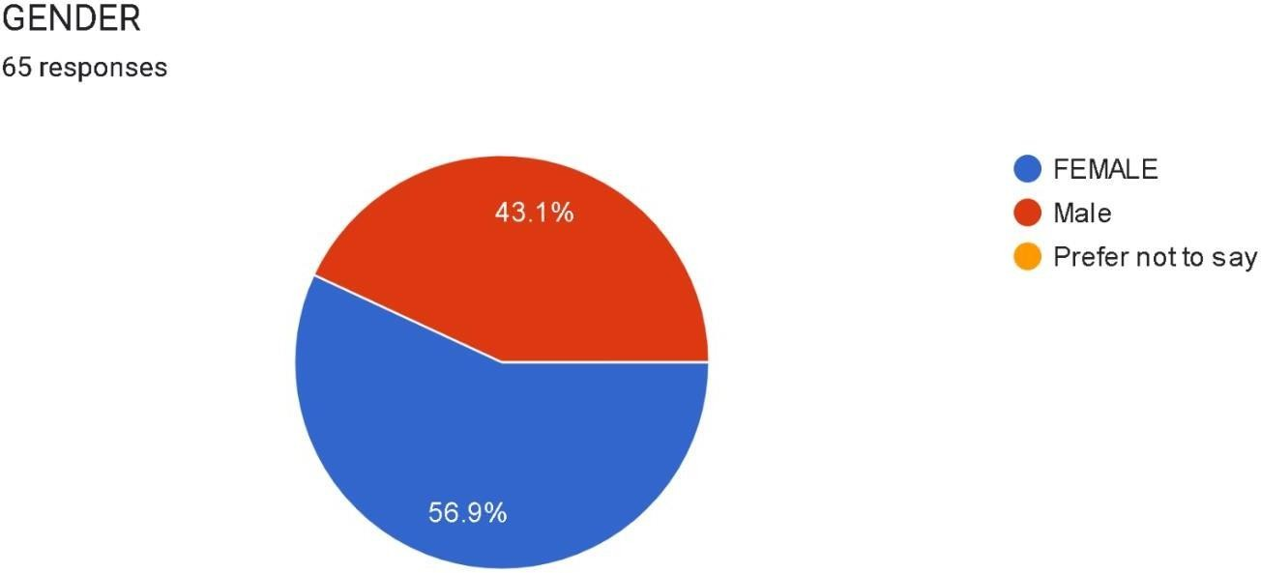

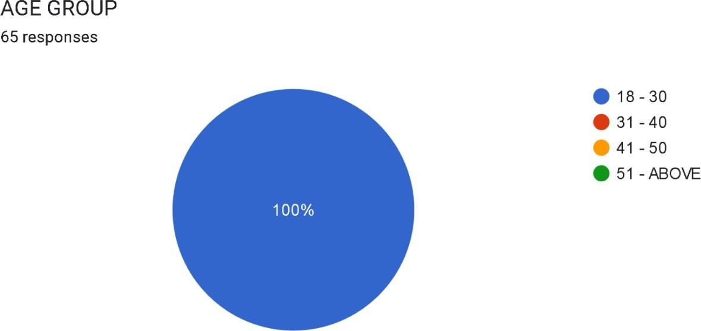

we have got 100% response between the age from 18-30 which include mainly students, employees, and businessmen. which means the majority population using e- banking includes between this age group.

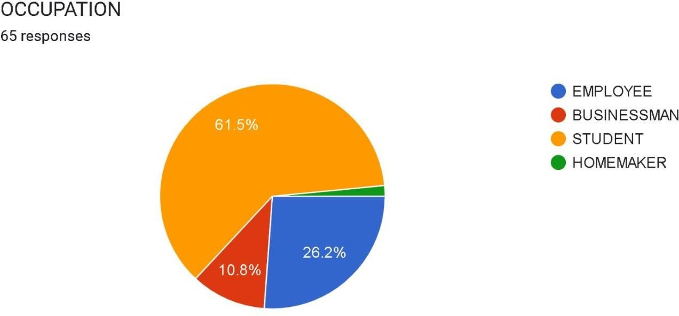

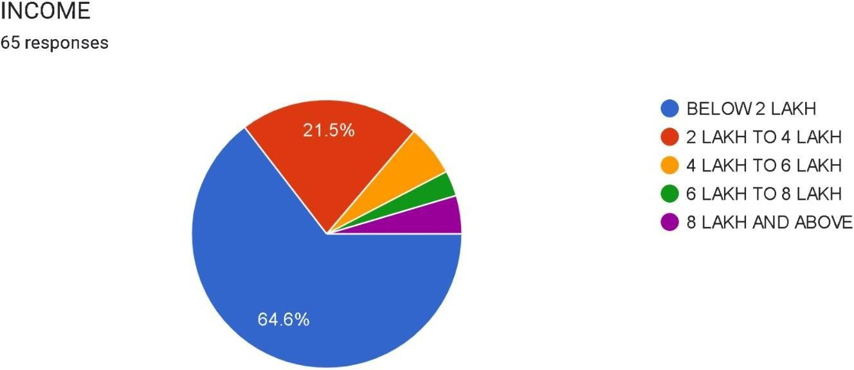

Majority of the income group lies between 2 lakh and 4 lakh this means they are salaried persons thus might be using e banking.

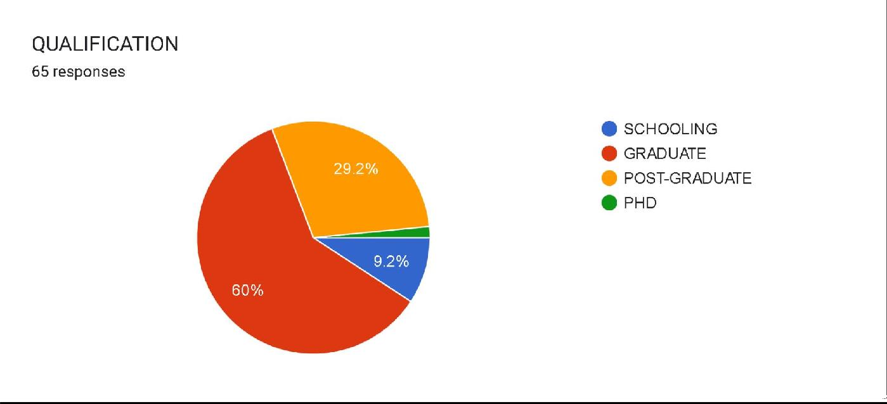

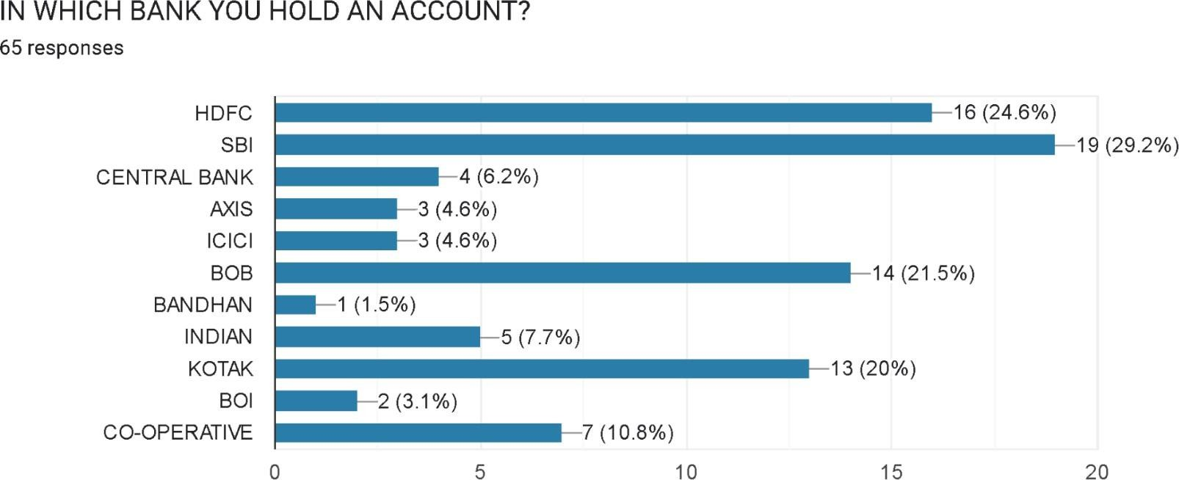

Majority of bank accounts are held in SBI bank and least is held with bandhan bank thus, we can say that sbi provides best e banking services than any other bank.

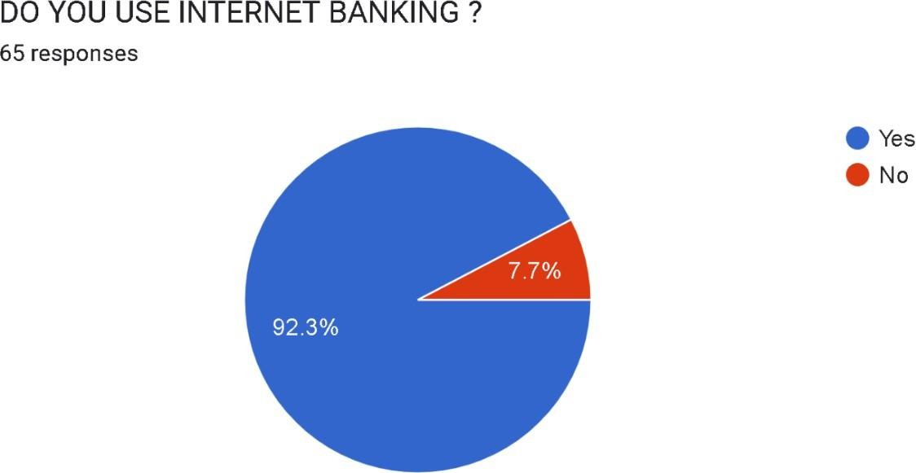

From data of 65 there are 60 persons using internet banking
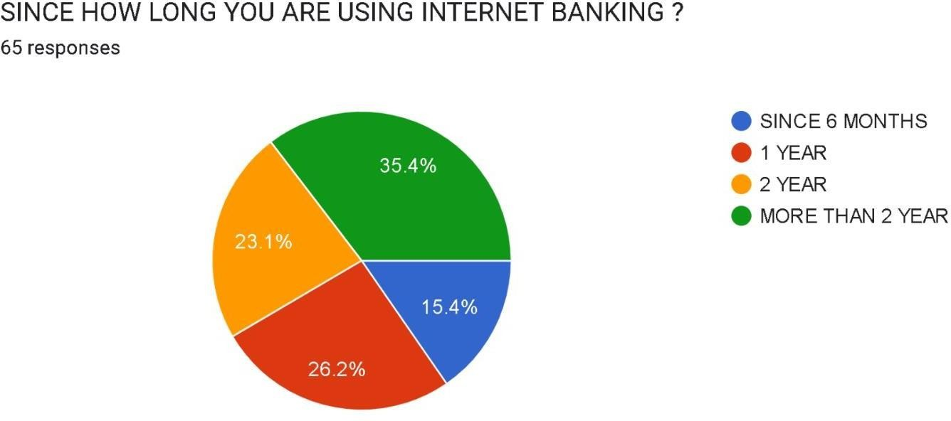

Here we can see that a maximum of 23 people have been using internet banking for more than 2 years.

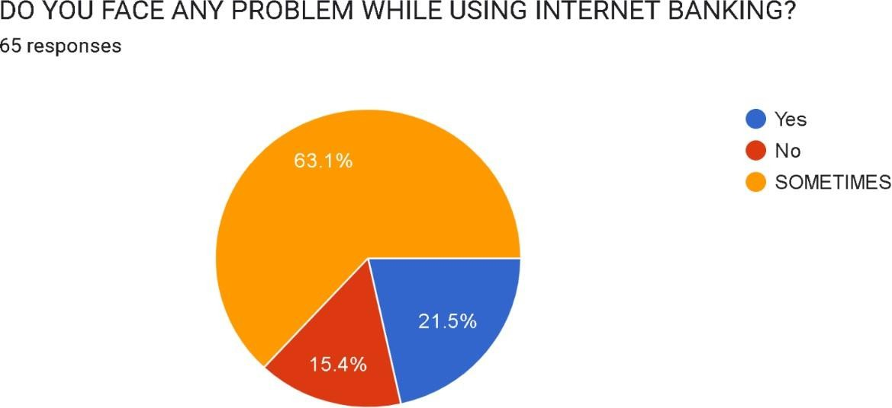

As ebanking is still evolving it still faces some problems while transaction thus maximum people have voted for sometimes.
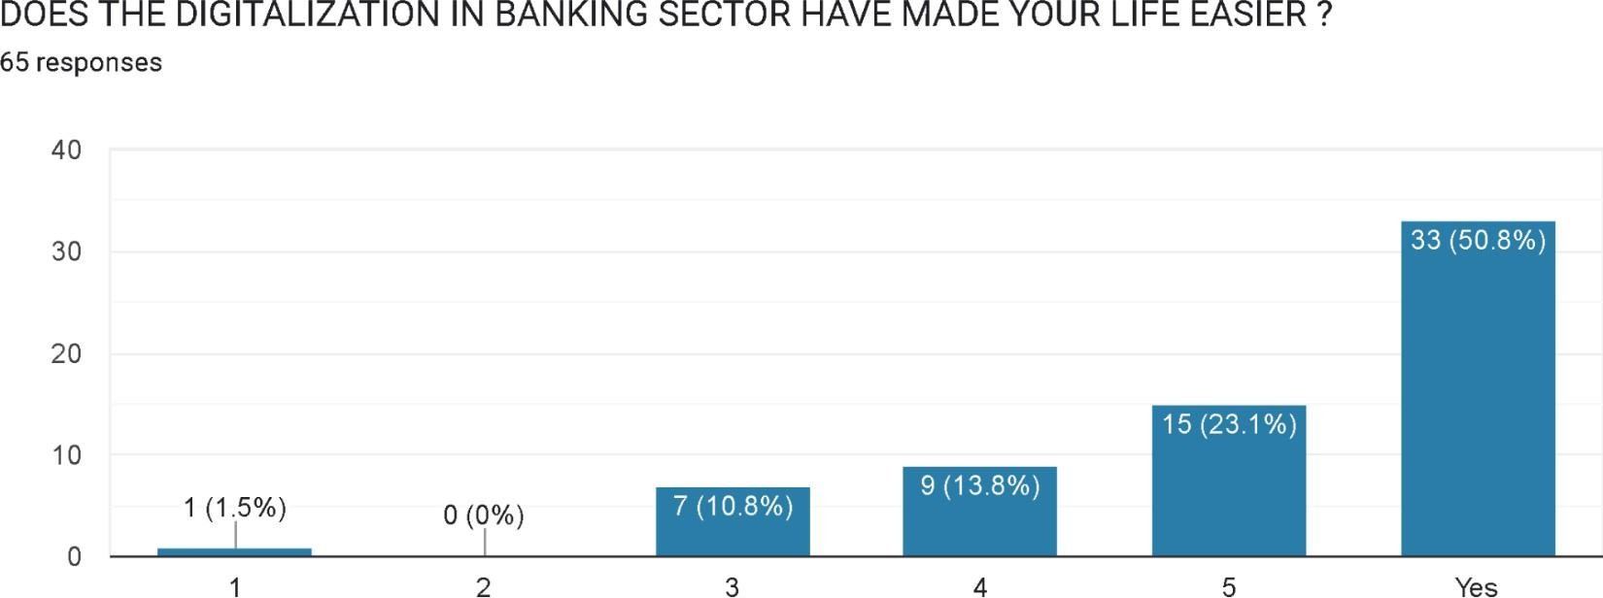

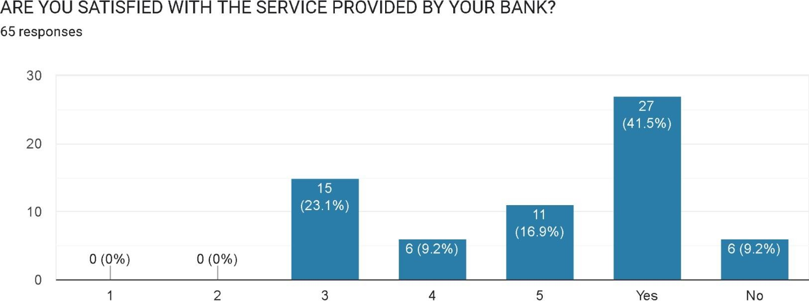

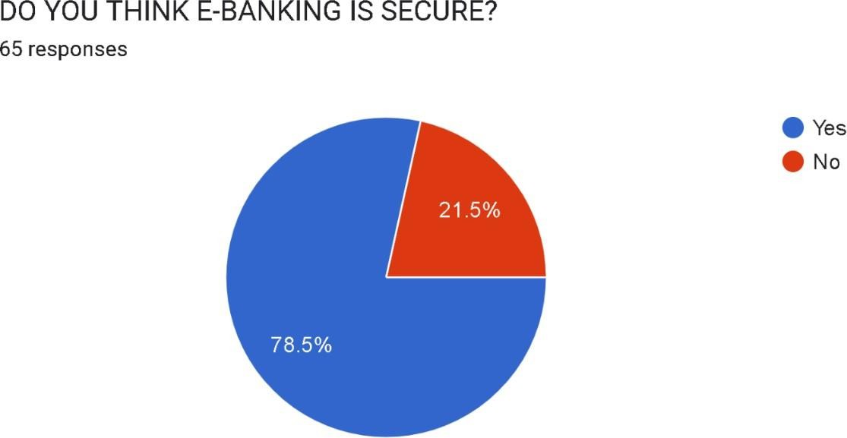

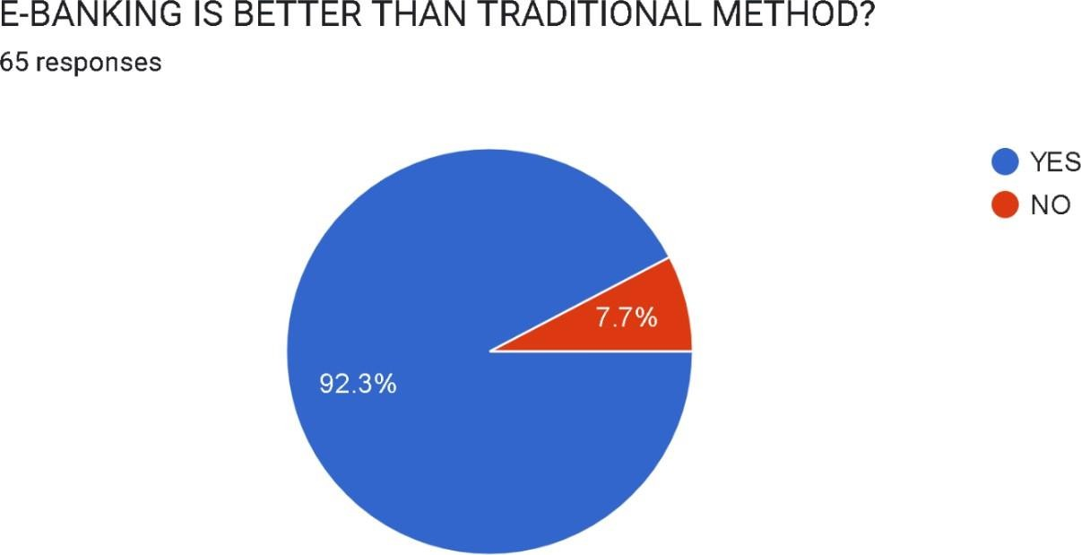

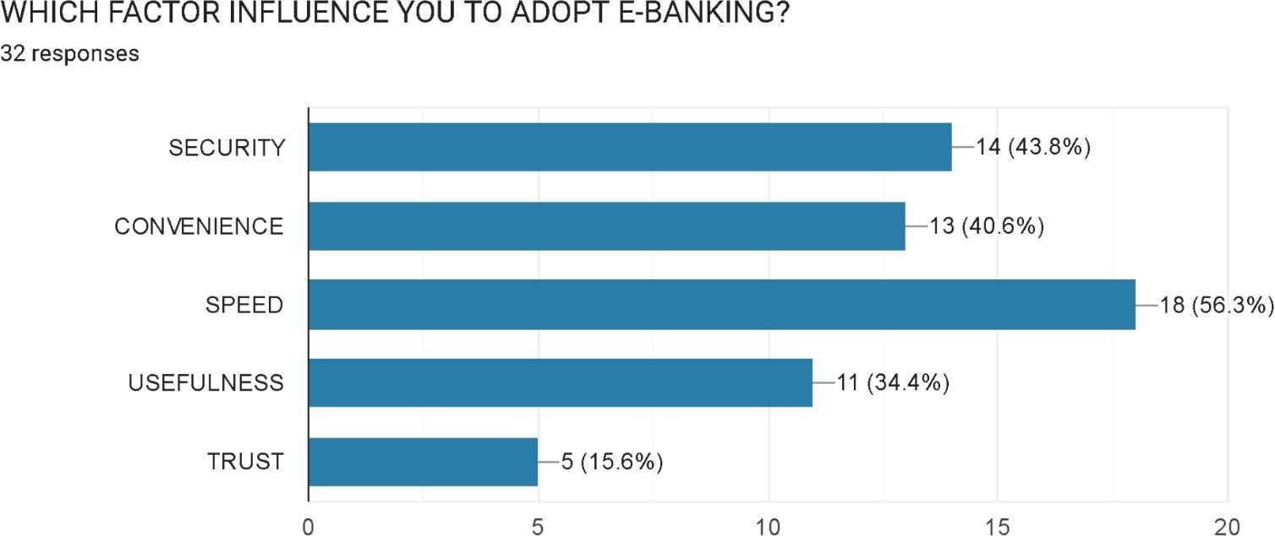

maximum people have voted for speed and security. Thus we can say that e-banking is being adopted by people for speed and security.

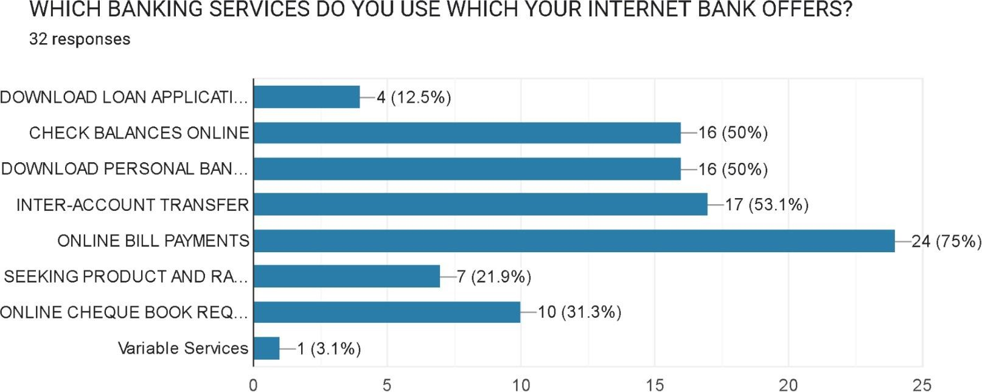

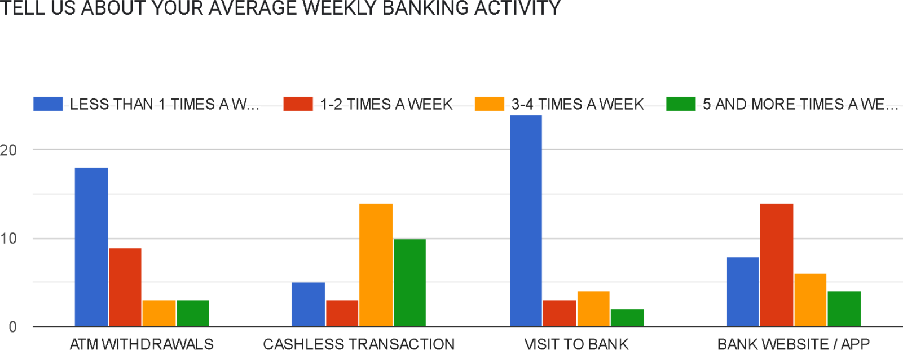

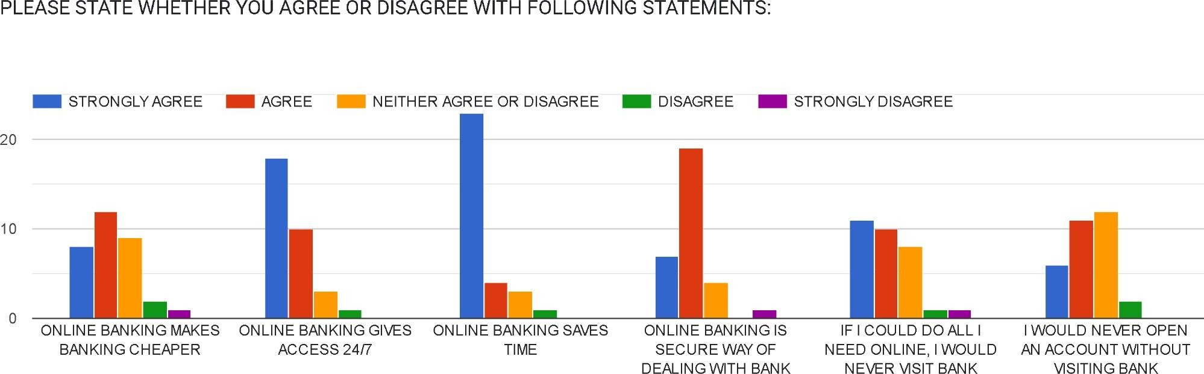

CHAPTER 5: CONCLUSION AND FINDINGS

CONCLUSION
Based on the comprehensive analysis of both primary observations and secondary data sources, it can be concluded that the pulp manufacturing process plays a crucial role in the overall functioning and efficiency of a paper mill. Pulp production serves as the foundation of paper manufacturing, as the quality, strength, and characteristics of paper largely depend on the effectiveness of the pulping process. The study highlights that modern pulp manufacturing has evolved significantly from traditional manual practices to highly mechanized and automated industrial operations.
The findings indicate that an efficient pulp manufacturing process requires proper coordination between raw material selection, chemical processing, mechanical operations, and quality control systems. The use of appropriate pulping methods, such as mechanical and chemical pulping, ensures optimum fiber separation while maintaining the desired strength and quality of the final product. Effective monitoring of process parameters like temperature, pressure, and chemical concentration helps in achieving consistent pulp quality and reducing production losses.

The study also reveals that operational management plays a vital role in improving productivity within a paper mill. Proper manpower utilization, regular machine maintenance, and systematic material handling significantly contribute to minimizing downtime and improving operational efficiency. Modern pulp mills increasingly rely on automated control systems and digital monitoring technologies, which enhance process accuracy and reduce human error.

Another important finding of the study is the growing emphasis on environmental sustainability in pulp manufacturing. Paper mills are adopting eco-friendly bleaching techniques, wastewater treatment systems, and energy-efficient technologies to reduce environmental impact. The increased use of recycled paper as a raw material has further supported sustainable production practices by conserving natural resources and reducing waste generation.

Furthermore, the research highlights that technological advancements and Industry 4.0 practices have transformed pulp manufacturing into a more data-driven and efficient process. Automation, real-time monitoring, and predictive maintenance systems help industries improve productivity, reduce operational costs, and ensure consistent product quality.

In conclusion, the pulp manufacturing process is not only a technical operation but also a strategic industrial activity that directly influences production efficiency, cost management, and environmental performance of a paper mill. Continuous improvement through technological innovation, sustainable practices, and effective operational management is essential for achieving long-term industrial growth. The adoption of modern manufacturing techniques and sustainable resource utilization will enable paper mills to meet increasing market demand while maintaining environmental responsibility and operational excellence.

FINDINGS

- From the overall study and process analysis, it was observed that pulp manufacturing is the most critical stage in paper production, as the quality of pulp directly determines the strength, texture, and durability of the final paper product.
- The study shows that the selection of raw materials such as wood, bamboo, and recycled paper significantly affects pulp quality and production efficiency. Mills using properly sorted and treated raw materials achieve better productivity and reduced wastage.
- It was found that chemical pulping methods produce stronger and higher-quality pulp compared to mechanical pulping, although chemical processes require higher operational control and chemical management.
- The analysis indicates that automation and computerized monitoring systems have improved operational accuracy, reduced manual errors, and ensured consistent pulp quality throughout the manufacturing process.
- Proper machine maintenance and scheduled inspections were identified as major factors in minimizing production downtime and improving overall plant efficiency.
- The research reveals that effective chemical recovery systems help reduce production costs and environmental pollution by reusing chemicals during the pulping process.
- Wastewater treatment and environmental management practices have become essential components of modern pulp manufacturing, helping industries comply with environmental regulations and sustainability standards.
- The study found that the use of recycled fiber has increased in modern paper mills, reducing dependency on natural resources and supporting eco-friendly production practices.
- Efficient manpower utilization and proper workflow management were observed to enhance productivity and ensure smooth coordination between different stages of pulp production.
- It was also observed that adoption of advanced technologies such as automation, data monitoring, and Industry 4.0 systems has improved decision-making, energy efficiency, and overall operational performance in paper mills.

CHAPTER 6: SUGGESTIONS AND RECOMMENDATIONS
- Adoption of Advanced Automation Systems: The industry should increase the use of automated monitoring and control systems in pulp production. Automation helps maintain process stability, reduces manual errors, and ensures consistent product quality. Smart sensors and digital control panels can monitor temperature, pressure, and chemical dosage in real time.
- Energy Efficiency Improvement: Pulp manufacturing is an energy-intensive process. The company should adopt energy-efficient machinery and optimize steam and power consumption. Waste heat recovery systems can be installed to reuse excess thermal energy, reducing operational costs and improving sustainability.

- Environmental Protection Measures: The industry should strengthen environmental management practices by improving wastewater treatment systems and reducing chemical discharge. Eco-friendly bleaching techniques such as Elemental Chlorine Free (ECF) or Totally Chlorine Free (TCF) processes should be encouraged to minimize environmental impact.
- Increased Use of Recycled Raw Materials: Utilizing recycled paper as a raw material can reduce dependency on natural wood resources and promote sustainable production. Proper segregation and treatment of recycled fiber can help maintain pulp quality while supporting environmental conservation.

- Regular Maintenance and Equipment Upgradation: Periodic maintenance of machinery should be ensured to avoid unexpected breakdowns and production losses. Upgrading outdated equipment with modern technology can improve productivity, reduce downtime, and enhance operational safety.

- Quality Control Enhancement: A strong quality control system should be implemented at every stage of pulp production. Laboratory testing of fiber strength, moisture content, and chemical composition should be conducted regularly to maintain product standards.

- Employee Training and Skill Development: Workers and technical staff should receive regular training programs related to modern pulp processing technologies, safety procedures, and quality control practices. Skilled manpower improves efficiency and reduces operational risks.
- Workplace Safety Improvements: The pulp manufacturing environment involves chemicals, heat, and heavy machinery. Proper safety equipment such as helmets, gloves, masks, and emergency response systems should be strictly implemented. Regular safety audits and awareness programs should also be conducted.

- Implementation of Industry 4.0 Technologies: The adoption of Industry 4.0 technologies such as data analytics, predictive maintenance, and smart monitoring systems can improve decision-making and production planning. Digital data analysis helps detect inefficiencies and optimize manufacturing operations.
- Waste Management and Resource Optimization: Solid waste generated during pulp processing should be reused wherever possible. By-products can be utilized for energy generation or secondary industrial applications, helping reduce waste disposal problems and improve resource utilization.

By implementing modern operational strategies and technological improvements, pulp manufacturing industries can significantly enhance production efficiency, product quality, and environmental sustainability. Over the years, several researchers and industrial experts have studied different aspects of pulp and paper manufacturing, including process optimization, automation, environmental management, and resource utilization.

Smook, G.A. (2002) analyzed the fundamental principles of pulp and paper manufacturing and emphasized the importance of proper fiber processing, chemical treatment, and quality control systems in achieving high-quality pulp production. The study highlighted that efficient raw material handling and controlled chemical processes directly influence final paper quality.

Biermann, C.J. (1996) examined pulp production technologies and concluded that improvements in pulping methods and bleaching techniques significantly enhance fiber strength and reduce environmental pollution. The research suggested adopting modern chemical recovery systems to minimize waste generation.

Gullichsen and Fogelholm (2000) studied modern chemical pulping processes and found that automation and process monitoring systems improve operational stability and reduce energy consumption. Their findings indicated that real-time monitoring helps industries maintain consistent product standards.

Bajpai, P. (2013) focused on environmental sustainability in pulp and paper industries. The study revealed that eco-friendly bleaching technologies and advanced wastewater treatment systems play a major role in reducing environmental impact. The researcher recommended adopting cleaner production techniques for sustainable industrial growth.

Singh and Kumar (2010) investigated productivity improvement in pulp manufacturing plants and observed that effective manpower utilization and preventive maintenance practices significantly reduce machine downtime and operational losses.

Hubbe and Bowden (2009) examined recycling practices in the paper industry and concluded that recycled pulp processing reduces dependence on virgin wood resources while supporting sustainable development. The study emphasized proper fiber recovery and contamination control during recycling.

Kocurek (1989) analyzed energy management in pulp mills and reported that energy optimization and heat recovery systems can substantially lower production costs. The research suggested integrating energy-efficient technologies to improve industrial profitability.

Thompson et al. (2015) studied automation and Industry 4.0 applications in manufacturing industries and found that digital monitoring, predictive maintenance, and data analytics improve decision-making and operational efficiency in modern pulp mills.
Monte et al. (2009) examined occupational safety in pulp and paper industries and highlighted the importance of safety training programs and protective equipment to minimize workplace hazards associated with chemicals and heavy machinery.

European Paper Industry Report (2018) emphasized sustainable manufacturing practices and recommended increased use of renewable energy sources, recycled fibers, and environmentally responsible production techniques to ensure long-term industrial sustainability.

World Business Council for Sustainable Development (WBCSD) Forest Products Industry Study (2020) focused on sustainability and circular economy practices in the paper industry. The study encouraged increased recycling of paper fibers, waste reduction strategies, and adoption of cleaner production technologies to improve resource efficiency and long-term environmental performance.

International Energy Agency (IEA) Industrial Energy Efficiency Report (2019) discussed energy consumption patterns in pulp and paper industries and recommended the use of energy-efficient boilers, heat recovery systems, and biomass-based energy generation to reduce operational costs and carbon emissions in pulp manufacturing plants.

CHAPTER 7: ANNEXURE

Survey Questionnaire
- Name:
- Gender:
  - male
  - female
  - prefer not to say
- Age:
1) 18-30 2) 31-40
- 41-50 4) Above 51
- Income:
1) Below 2 Lac 2) 2 lac to 4 lac
3) 4 lac to 6 lac 4) 6 lac to 8 lac
- 8 lac and above
- Occupation
1) Homemaker 2) Businessman
3) Employee 4) Student
- Qualification
1) Schooling 2) Graduate
3) Post Graduate 4) PHD
- In which Bank you hold an account?
1) SBI 2) HDFC
3) ICICI 4) Bank of Baroda
5) Central Bank of India 6) Bandhan
7) Indian 8) Kotak
9) Central Bank 10) BOB
11) BOI

- Do you use Internet Banking?
1) Yes 2) No
- Since how long have you been using Internet Banking?
1) Since 6 months 2) Since 2 Years
3) Since 1 year 4) More than that
- Do you face any problem while using Internet Banking?
1) Yes 2) No
3) Sometime
- Does the Digitalization in Banking Sector have made your life easier?
1) Yes 2) No
- Are you satisfied with the Internet services provided by your Bank?
1) Yes 2) No
- Do you think E-banking is secure ?
  - Yes b) No
- Is E-Banking better than the traditional method ?
  - Yes b) No
- Which factor influence you to adopt E- banking
  - security
  - convenience
  - speed

  - usefulness
  - trust
- Which banking service do you use which your internet bank offers ?
  - download loan application
  - check balance online
  - download personal bank transaction history
  - inter-account transfer
  - online bill payment
  - seeking product and rate information
  - online cheque book request
  - other
- Tell us about your average weekly banking activity?
  - ATM Withdrawals
  - Cashless Transactions
  - Visit to bank
  - Bank website / app

- Please state whether you agree or disagree with the following statement?
  - Online banking makes banking cheaper.
  - Online banking gives access 24/7.
  - Online banking saves time.
  - Online banking is a secure way of dealing with banks.
  - If I could do all I need online, I would never visit a bank.
  - I would never open an account without visiting the bank.

CHAPTER 8: REFERENCES AND BIBLIOGRAPHY
Bajpai, P. (2018). Pulp and Paper Industry: Chemicals and Processes. Elsevier Publications. Retrieved from industrial process literature on pulp manufacturing and chemical pulping technologies.

Biermann, C. J. (1996). Handbook of Pulping and Papermaking. Academic Press, San Diego. This book provides detailed explanations of pulp production methods and paper manufacturing processes.

Gullichsen, J., & Fogelholm, C. J. (2000). Chemical Pulping. Papermaking Science and Technology Series, Finnish Paper Engineers’ Association. A comprehensive reference on kraft pulping and bleaching operations.

Smook, G. A. (2002). Handbook for Pulp and Paper Technologists. Angus Wilde Publications Inc. This handbook explains industrial pulp processing, machinery, and quality control techniques.

Singh, R. P. (2015). Industrial Engineering and Production Management. S. Chand Publications. Used for understanding production workflow and operational management in manufacturing industries.

Kocurek, M. J. (1989). Pulp and Paper Manufacture: Mechanical Pulping. TAPPI Press. Provides insights into mechanical pulping technologies and fiber processing systems.

McKetta, J. J. (1992). Encyclopedia of Chemical Processing and Design. CRC Press. Reference for chemical reactions and industrial processing methods used in pulp production.

Bajpai, P. (2013). Biotechnology for Pulp and Paper Processing. Springer Publications. Discusses environmentally sustainable and modern pulp bleaching techniques.

6.2 WEBSITES
https://www.tappi.org
Official Website of Central Pulp & Paper Research Institute, Saharanpur U.P, DIPP | Ministry of Commerce and Industry, Government of India.
Forestry | FAO | Food and Agriculture Organization of the United Nations
Pulp and Paper Resources on the Web | PaperonWeb
IPPTA – Indian Pulp & Paper Technical Association
https://www.sciencedirect.com/
https://www.elsevier.com/

End of Project Report

